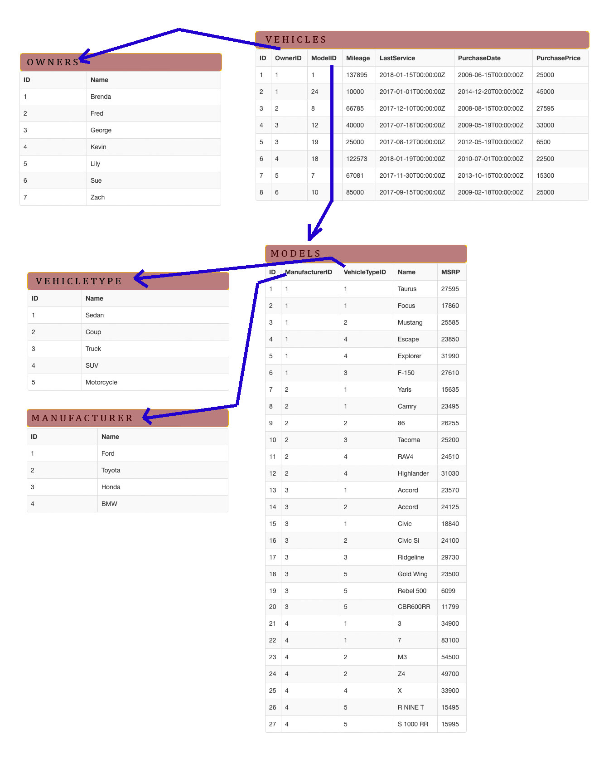

/* Owners (Name) */

/* VARCHAR */

/* Manufacturer (Name) */

/* VARCHAR */

/* VehicleType (Name) */

/* VARCHAR */

/* Models ( ManufacturerID, VehicleTypeID, Name, MSRP ) */

/* INT INT VARCHAR MONEY */

/* Vehicles( OwnerID, ModelID, Mileage, LastService, PurchaseDate, PurchasePrice) */

/* INT INT INT DATETIME DATETIME MONEY */

**1 How many vehicle models per manufacturer?**

SELECT

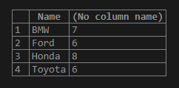 Manufacturer.Name, COUNT(Models.ManufacturerID) as count

FROM

Models, Manufacturer

WHERE

Models.ManufacturerID = Manufacturer.ID

GROUP BY

Manufacturer.Name

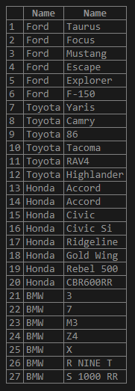**answer**

SELECT

Manufacturer.Name, Models.Name

FROM

Models, Manufacturer

WHERE

Models.ManufacturerID = Manufacturer.ID

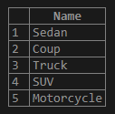**2 Per Vehicle Type?**

**answer**

SELECT Name FROM VehicleType;

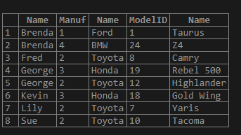**3 How many cars does each owner possess?**

SELECT

Owners.Name,

Models.ManufacturerID AS Manuf,

Manufacturer.Name as Brand,

Vehicles.ModelID,

Models.Name as Model

FROM

Vehicles, Owners, Models, Manufacturer

WHERE

Vehicles.ModelID = Models.ID AND

Models.ManufacturerID = Manufacturer.ID AND

Vehicles.OwnerID = Owners.ID

ORDER BY

Owners.Name

**answer**

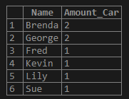SELECT

Owners.Name, COUNT(Owners.Name) as Amount_Car

FROM

Vehicles, Owners, Models, Manufacturer

WHERE

Vehicles.ModelID = Models.ID AND

Models.ManufacturerID = Manufacturer.ID AND

Vehicles.OwnerID = Owners.ID

GROUP BY

Owners.Name

ORDER BY

Amount_Car DESC, Owners.Name

**4 How many total miles are logged to each owner?**

SELECT Owners.Name,

Vehicles.Mileage,

Manufacturer.Name AS Brand ,

Models.Name AS Model,

DATEDIFF(year, CONVERT(VARCHAR,Vehicles.PurchaseDate,101), CONVERT(VARCHAR,Vehicles.LastService,101)) as year

FROM

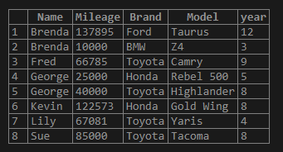 Vehicles, Owners, Models, Manufacturer

WHERE

Vehicles.OwnerID = Owners.ID AND

Vehicles.ModelID = Models.ID AND

Models.ManufacturerID = Manufacturer.ID

ORDER BY

Owners.Name

**answer**

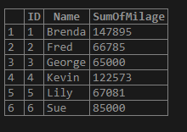SELECT

Owners.ID,

Owners.Name,

SUM(Vehicles.Mileage) as SumOfMilage

FROM

Vehicles, Owners

WHERE

Vehicles.OwnerID = Owners.ID

GROUP BY

Owners.ID, Owners.Name